CS 2302 – Project 5, Option B  
Professor Diego Aguirre  
Victor Huicochea – 80643271

**Project 5 – Heaps-**

**Introduction**

The purpose of this project is to practice the use of Heaps. The lab should be an implementation of Min-Heap and a HeapSort algorithm. The HeapSort should be tested out with either reading a file or generating a hard-coded list of numbers.

**Proposed Solution**

Two different files were written to solve this project. One of them contains the class for the Heap, and the other one is the Main program, where all operations are done.

The Main program contains several functions. One of them creates an array filled with random numbers. Another one is the heap sort algorithm. Lastly, the main method prints the options for the user and lets him decide what operation to perform.

Running Time Graph

**Experimental Results**

1.- Testing with a string as an input.

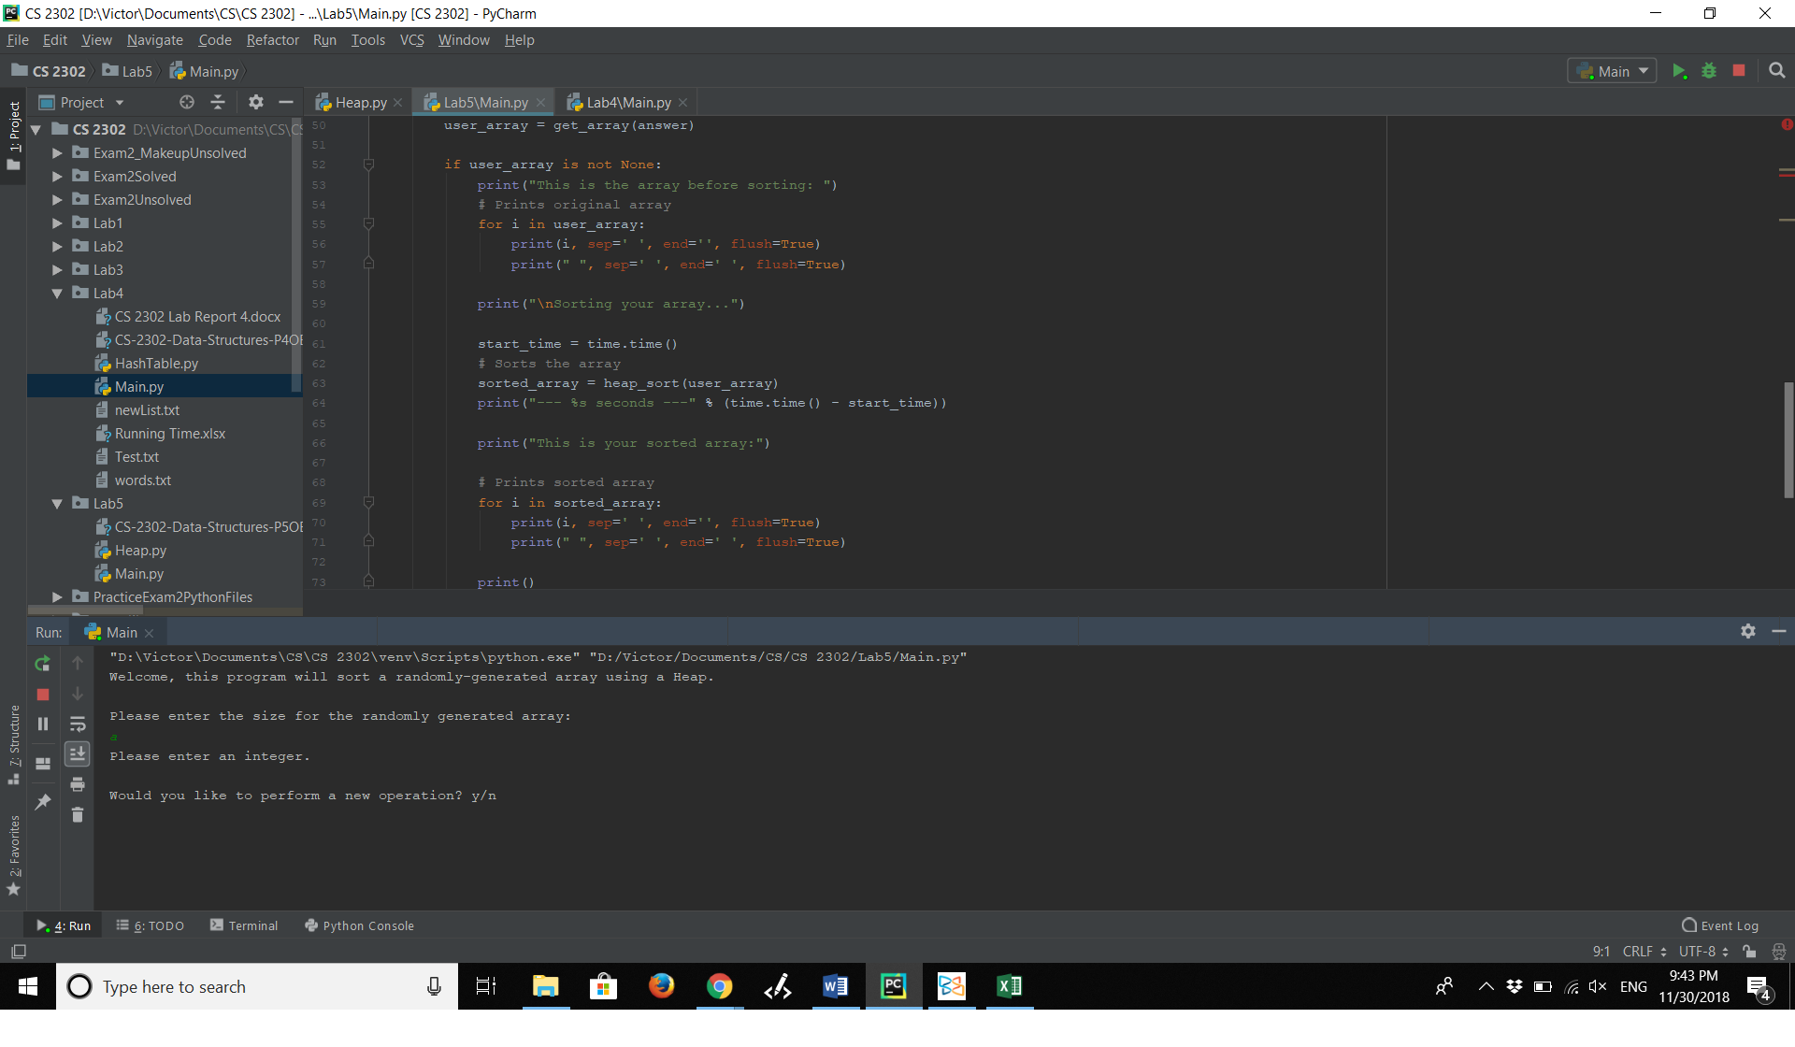

2.- Testing with decimal number.

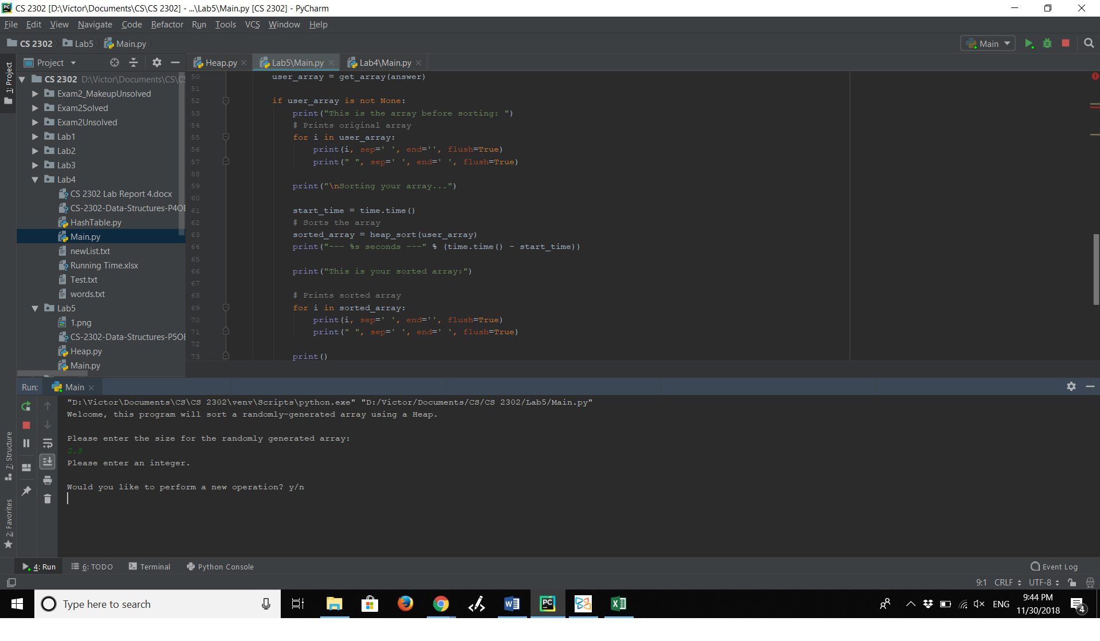

3.- Testing with 0.

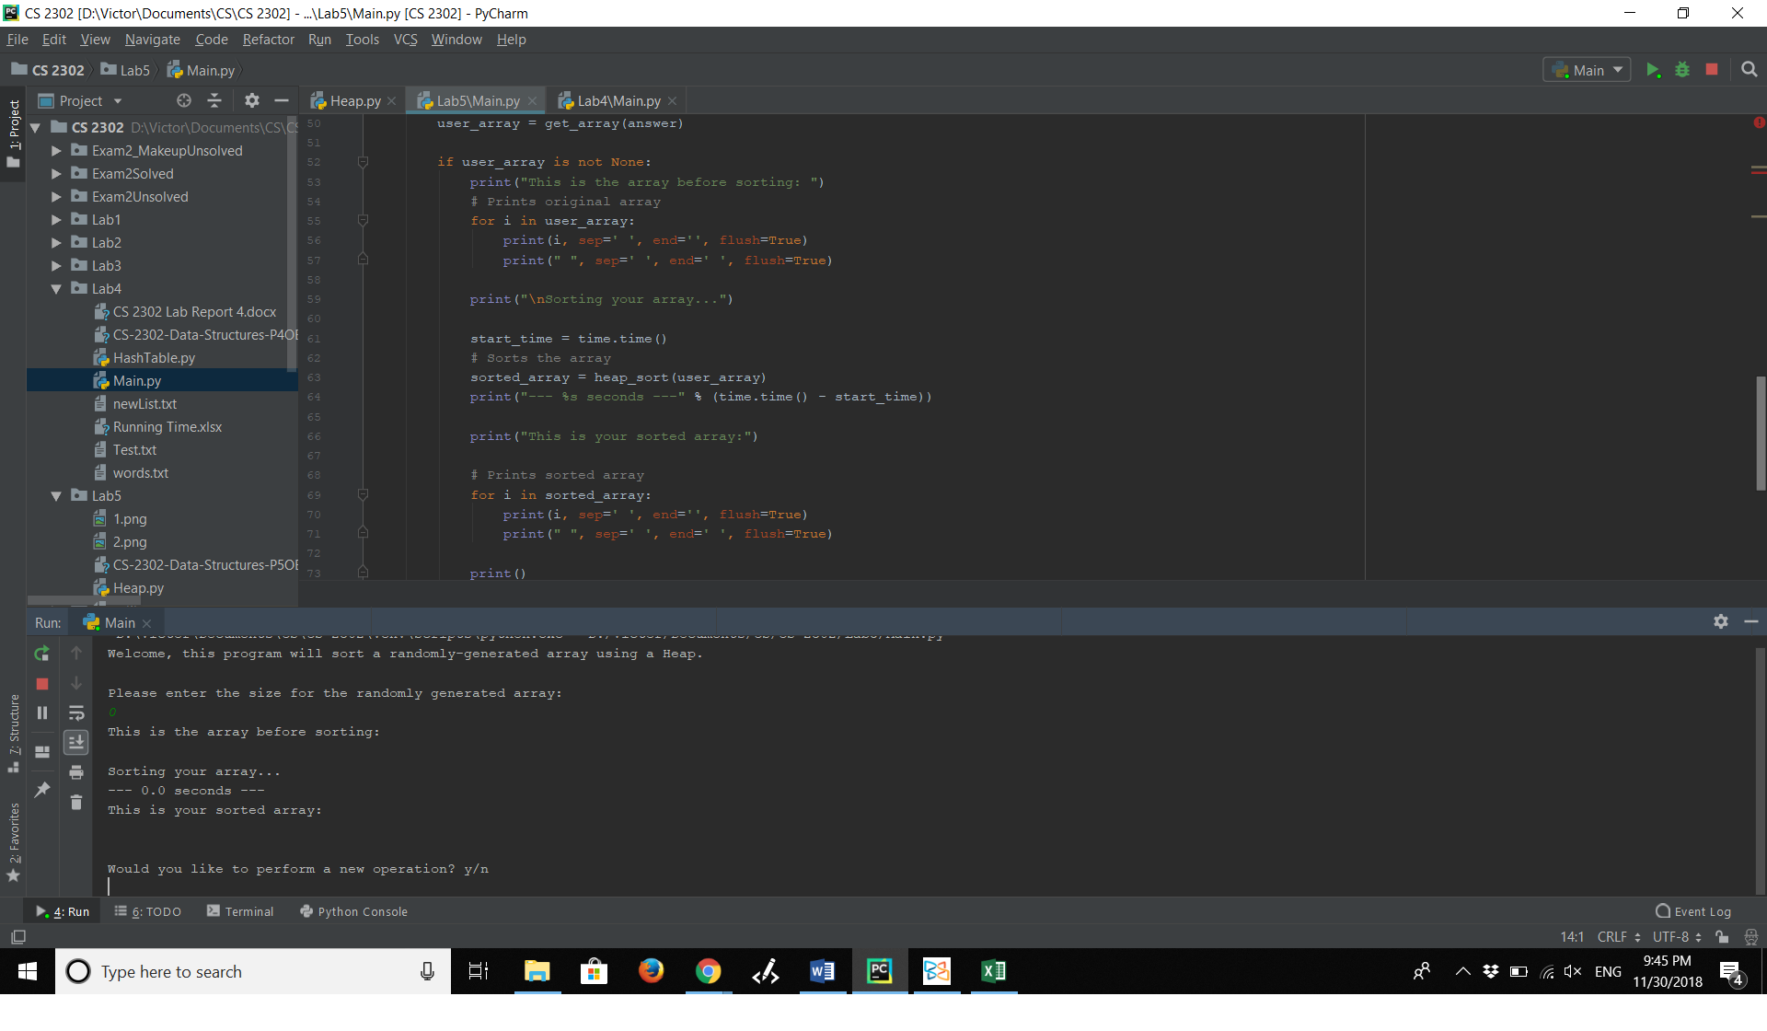

**Conclusions**

This project helped me to understand the use of Heaps. Now I feel more comfortable working with heaps since I am now more capable of visualizing how data moves after every function.

I also understood how the heap sort algorithm works. I can now visualize how the data gets sorted and distinguish when it is better to use Heaps.

**Appendix – Source Code**

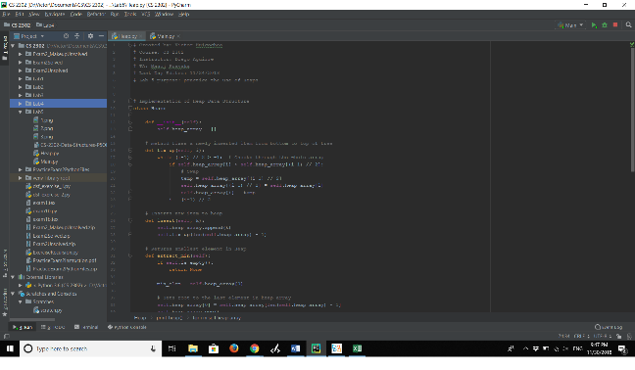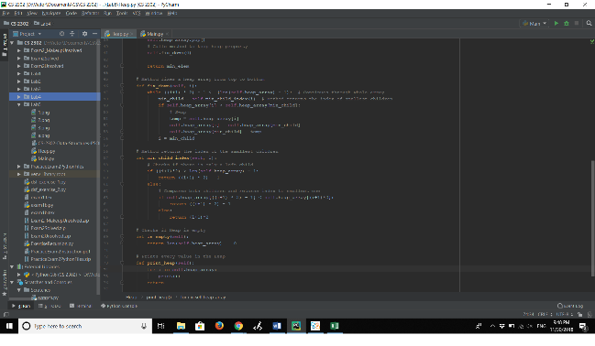

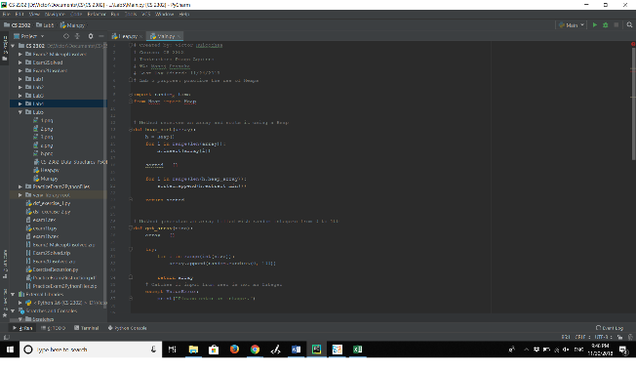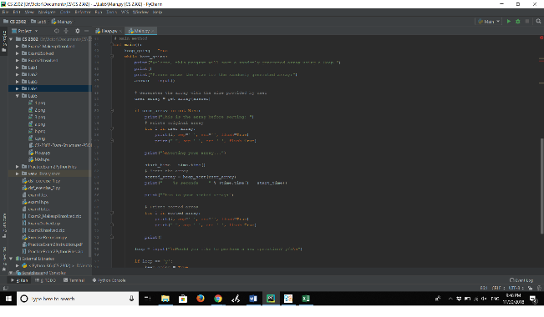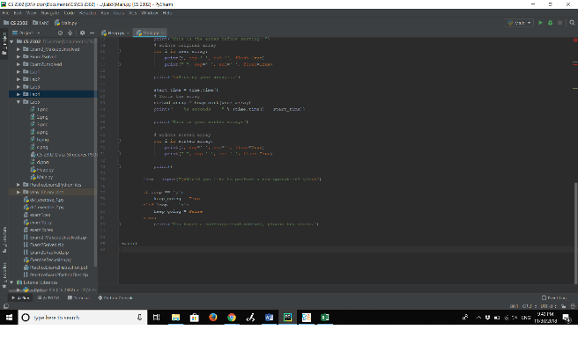

**Academic Honesty Certification**

****I certify that this project is entirely my own work. I wrote, debugged, and tested the code being presented, performed the experiments, and wrote the report. I also certify that I did not share my code or report or provided inappropriate assistance to any student in the class.